Practical No 1

Aim: Design and implement algorithms to encrypt and decrypt messages using classical substitution and transposition techniques.

Caesar Cipher

def caeser(text, key):
min = ord('a')
max = ord('z')
size = min + max + 1

result = ''

for char in text:
text_char = ord(char)
cipher = min + ((text_char - min + key) % size)
result += chr(cipher)

return result

def decrypt_caeser(text, key):
min = ord('a')
max = ord('z')
size = min + max + 1

result = ''

for char in text:
text_char = ord(char)
cipher = min + ((text_char - min - key) % size)
result += chr(cipher)

return result

plain_text = input("Enter Plain Text : ").lower().strip()
cipher_text = caeser(plain_text, 5)

print("Plain Text : ", plain_text)
print("Cipher Text : ", cipher_text)
print("Decrypt Text : ", decrypt_caeser(cipher_text, 5))
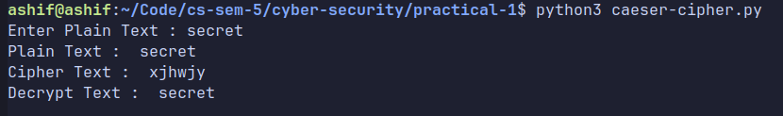

Rail Cipher

for key = 2
def encrypt(text):
even = ""
odd = ""

# Read the character
for i in range(len(text)):
if i % 2 == 0:
even += text[i]

else:
odd += text[i]
return even + odd

def decrypt(cipher):
text = ""

mid = (len(cipher) + 1) // 2
even = cipher[:mid]
odd = cipher[mid:]

for i in range(len(odd)):
text += even[i]
text += odd[i]

if len(even) > len(odd):
text += even[-1]

return text

msg = input("Enter message: ")

enc = encrypt(msg)
print("Encrypted: ", enc)

dec = decrypt(enc)
print("Decrypted: ", dec)

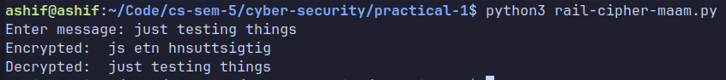

For Key = n
def rail_fence_encrypt(text, key):
if key <= 1:
return text

rails = [''] * key

rail = 0
direction = 1 # 1 = down, -1 = up

for char in text:
rails[rail] += char

if rail == 0:
direction = 1
elif rail == key - 1:
direction = -1
rail += direction

return ''.join(rails)

def rail_fence_decrypt(cipher, key):
if key <= 1:
return cipher

# Mark zigzag positions
pattern = [['' for _ in cipher] for _ in range(key)]

rail = 0
direction = 1

for col in range(len(cipher)):
pattern[rail][col] = '*'

if rail == 0:
direction = 1
elif rail == key - 1:
direction = -1

rail += direction

# Fill marked positions
index = 0
for r in range(key):
for c in range(len(cipher)):
if pattern[r][c] == '*':
pattern[r][c] = cipher[index]
index += 1

# Read zigzag
result = []

rail = 0
direction = 1

for col in range(len(cipher)):
result.append(pattern[rail][col])

if rail == 0:
direction = 1
elif rail == key - 1:
direction = -1

rail += direction

return ''.join(result)

plain_text = input("Enter Plain Text : ")
key = int(input("Enter Key : "))
cipher_text = rail_fence_encrypt(plain_text, key)

print("Plain Text : ", plain_text)
print("Cipher Text : ", cipher_text)
print("Decrypt Text : ", rail_fence_decrypt(cipher_text, 5))

